Laboratory work 1. WORD

1.1 Purpose of the work: to study the possibilities of the editor; Acquisition of skills of working with various formatting objects (texts, tables, figures, diagrams, related data), as well as with the tapes and tools of the program.
1.2 Work assignment:
1. Form the report cover sheet on the sample in Appendix 1.
2. From the next page set the page numbering and leave the page empty (further on it you will need to make the table of contents of the report).
3. Guided by the sample in Appendix 2, write your resume.
4. Configure the Quick Access Toolbar (in different color schemes), as shown in Figures 1 and 2. Press the PrintScreen key on the keyboard, save the resulting drawings in .jpg format, import them into the report.
Figure 1 - View of the Quick Access Toolbar

Figure 2 - View of the Quick Access Toolbar
5. Type the text and format it, as shown below:
1. Posters A2 ------ 5 pcs.
2. Paper100 --------- 5 pcs.
ϖ Format A3 ------- 7 pcs.
ϖ Format A4 ------- 4 pcs.
3. Notebooks ---------- 11 pcs.

6. Type any text and format it in the styles shown in Figure 3.
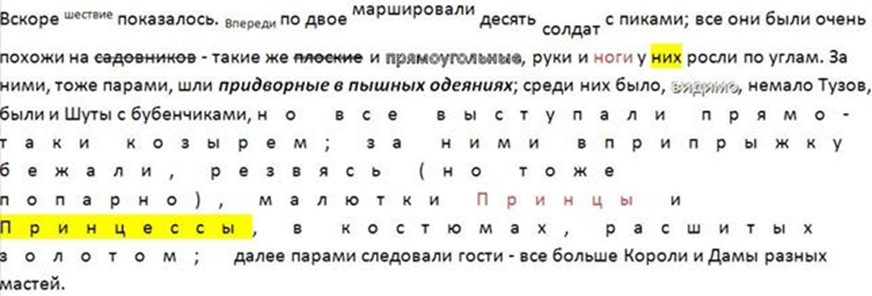
Figure 3 - Example sample for formatting
7. Type your own text, apply the effects as in Figure 4. Insert the breaks of the section before and after the page. Make an arbitrary page frame.
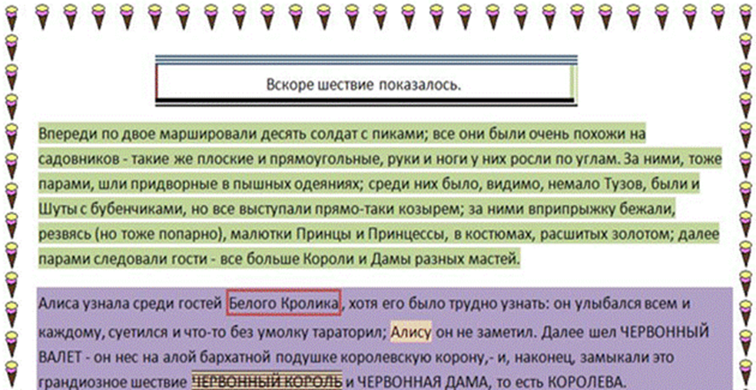
Figure 4 - Example sample for formatting

8. Build the table, format it, an example of the format is shown in Table 1.
Table 1 - Example table

Это  Одна  ячейка |  |  | 123 | 456
 |  | Это одна ячейка
This is one cell
9. Create 2 tables: the first is given in the explanations of the implementation of the guidelines below paragraph 9, and in the second give similar examples of the use of functions for ABS, AVERAGE, COUNT, INT, ROUND.
10. Create a table by model (see table 2). Fill it with the data, summarize and build the diagram.
Table 2 - Data table for example
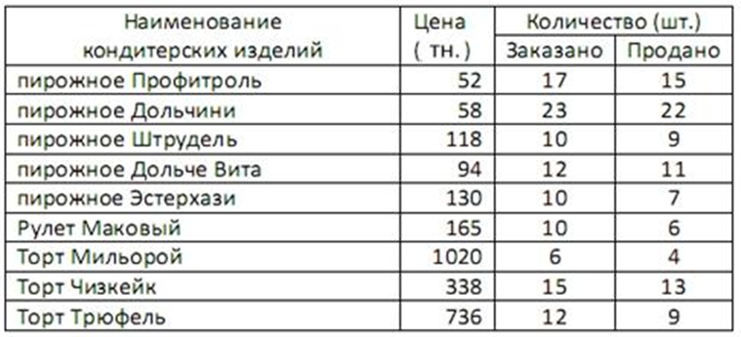
11. Develop your style to any 3-columned text. Apply this style to any paragraph in the report. Set a bookmark on your page with your style.
12. Using the tools of the Formula panel, write down the formula for the mass of the earth's atmosphere and the algebraic expression
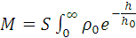dh=5*10¹⁵m 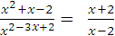.

13. Give any example of using 3-4 links and notes.
14. Use any of your choice of drawing objects, add a shadow to them, group all objects.
15. Create serial letters on an arbitrary subject to any addressee.
16. Make the header, paste in it the date, time and title fields of the document.
17. Write your answers to the test questions.
18. Create a report in the report that will contain your name and surname.
19. Go back to page 2 and create a report table of contents, having previously marked the "titles 1-3" of the job titles in the entire report.
20. Put the protection on the document.

